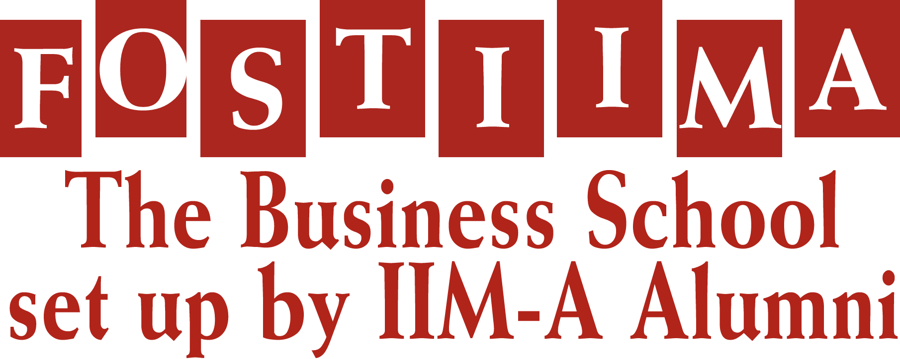

**KARISHMA SONDHI**

Female, 21 Years, **Mob:** +91-9899042284,

**E-mail Id:** karishma.sondhi@fostiima.org

**SUMMER INTERNSHIPS Duration: 2 Months**

**Career Objective:**Aspiring to handle assignments with an Organization of repute.

**Organization:** edVenture Learning Pvt. Ltd.(lerrnn)

**Department:** Online Marketing

**Designation: I**ntern

**Key Responsibility Areas:**

* To promote the company pages on social networking sites such as facebook, twitter and linkedin etc.
* To generate followers for these pages by posting new & interesting content and following tactics
* To record various activities such as new followers posting time and comments, most followed page etc.
* To follow up and re-tweet on the new posts and resolving any queries
* Read and analysed various case studies relevant to company’s business

**Learning:**

* Working on hootsuite (software) to manage the posts on multiple networking sites simultaneously
* Online promotion techniques- value and process
* Interesting TED Talks videos were good source of sharing knowledgeable posts

**EDUCATIONAL QUALIFICATION**

|  |  |  |  |
| --- | --- | --- | --- |
| **Class / Course** | **Year** | **School / College** | **%age/ Grades** |
| MBA | 2013-15 | FOSTIIMA Business School,New Delhi | Pursuing |
| BBA | 2013 | Ideal Institute of Management & Technology  (IP University) | 70 |
| Class XII | 2010 | Salwan Public School, Delhi | 78 |
| Class X | 2008 | Salwan Public School,Delhi | 81.6 |

**PROJECTS UNDERTAKEN**

* Project title :Report on the Brand Image of Britannia
  + To review the perception level of brand image of customers build by Britannia .
  + To analysis the customer response & their suggestions.
  + Collecting survey by preparing annexure
* Project title : Opening up of martial arts academy (herioc) .
* Idea was to start an academy in the residential area exclusively for women.
* Analysing this opportunity in the light of technical & financial feasibility
* Evaluating the techniques of promoting my academy taking in its cost considerations.
* Project title : Power Point Presentation on Credit Card Loyalty Program.
* Full description on credit cards & their loyalty programs
* Creating own loyalty program for AMEX
* Knowing earn & burn ratio for the bank & customers.

**AWARDS & ACHIEVEMENTS**

* Attained 1st Position in Camel Poster school Carnival
* 2nd Runner-up in NewU Advertisement competition (group level)
* 3rd position holder at Dance Mahotsav for consecutive two-years (2007-09)
* Cleared group 2 at D.I.D (Dance India Dance) 2010

**EXTRA CURRICULAR ACTIVITES & INTERESTS**

* Interest in managing events and an active member of Cultural Committee at FOSTIIMA
* Reading Novels and favorite book being ‘Connecting the dots’: Rashmi Bansal
* Dancing & Listing to music
* Travelling to new Places

**KEY SKILLS & ATTRIBUTES**

* Proficient in MS Office- Power point being the strongest
* Good networking skills
* Good communication & Interpersonal skills
* Punctual
* Hard working, Enthusiastic and Honest